**Key Points in the Project**

* **Environment Setup Part 1 at 3:39**:

If key pair is not available, choose “Create a new key pair” and give Key pair name as “twitter_analysis” (or any name which needs to be followed throughout this project)

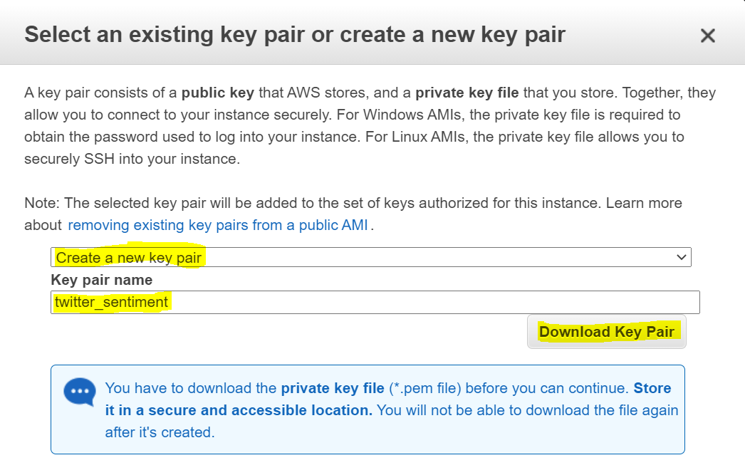

* **Environment Setup Part 1 at 5:00:**

Paste Public DNS after username@(ec2-user@ in this example)

* **Environment Setup Part 2 at 00:16:**

Place the .pem file somewhere in your local system and refere with absolute path in ***ssh*** and ***scp*** commands.

* When issuing ***ssh,*** you will encounter a warning (Are you sure you want to continue connecting (yes/no)?) and the answer is ***yes***.
* **Environment Setup Part 2** **at 10:50:**

The command is ***ls***

* **ModelCreation DatasetExplorationAndBucketization at 00:40:**

Download Sports and Outdoors 5-crore dataset

* **Extraction topic and publishing:** One can enter into docker container with docker container name or id

docker exec -i -t docker_name/dockerid bash

* **Connection reset:**

If the following error is seen in port forwarding cmd then terminate the window and issue the same command in the new cmd terminal.

*Connection reset by 18.237.23.123 port 22*

* **Twitter App Creation:**

Follow this procedure to create a Twitter app

* Click on the link to **create a Twitter developer account**. After clicking the link, the following page will appear.

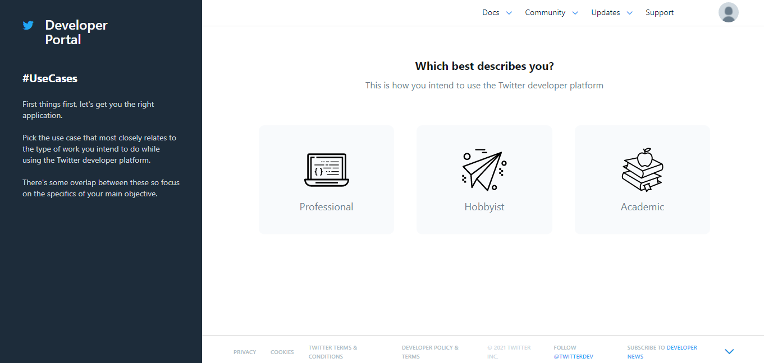

* Select Professional or whichever best describes you.

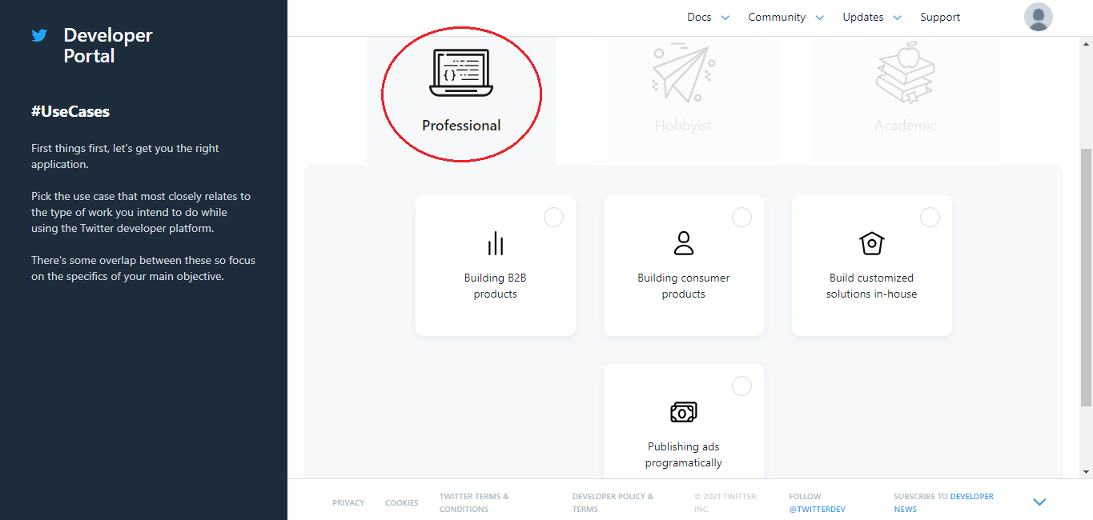

* Select the Building consumer products option and finally get started.

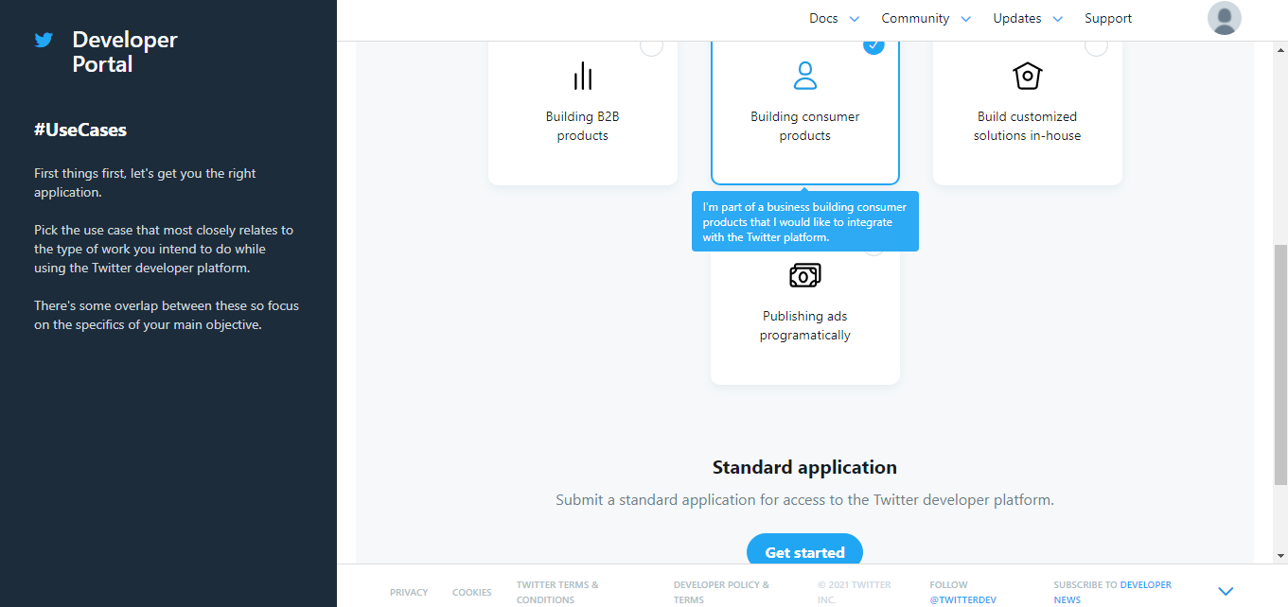

* Review the Basic info.

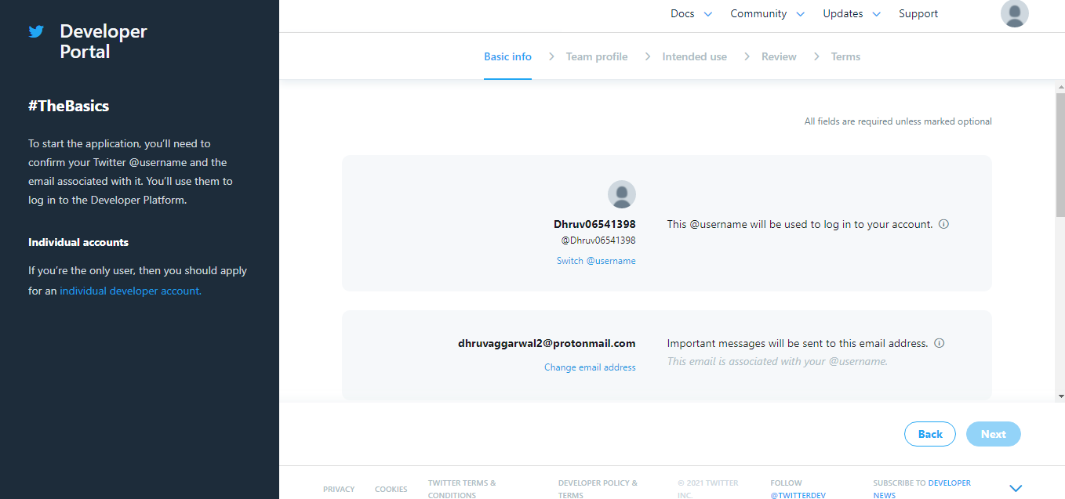

* Review the Basic Info and Click Next option.  
  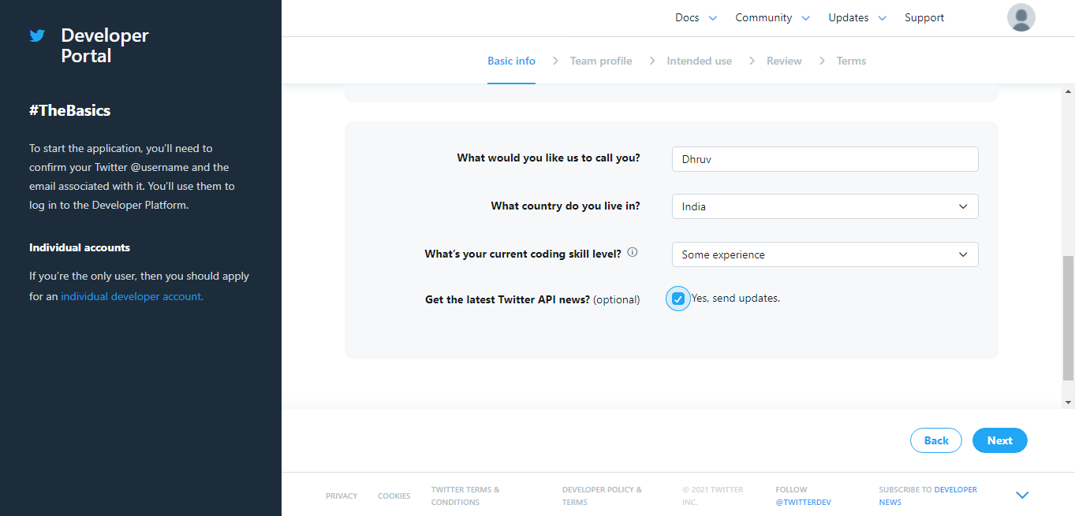
* Choose an Individual Developer Account.  
  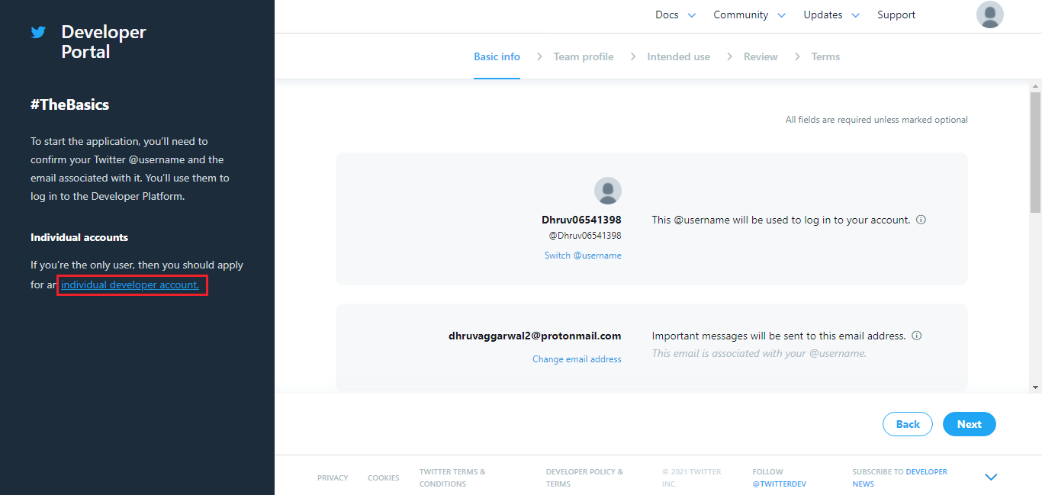
* Fill in the use of the developer account.  
  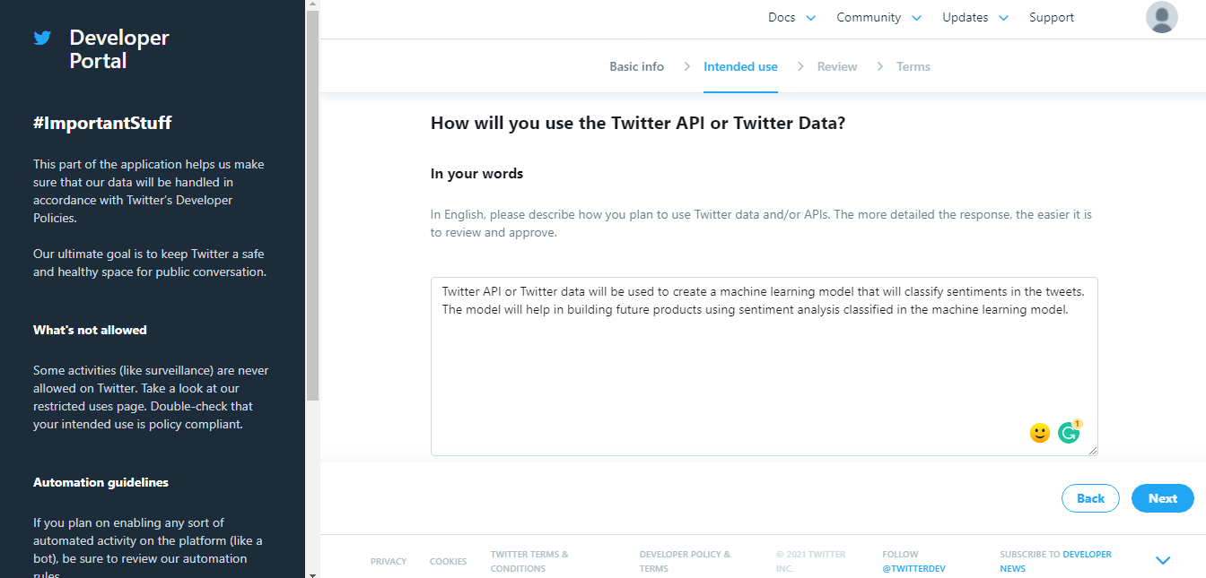

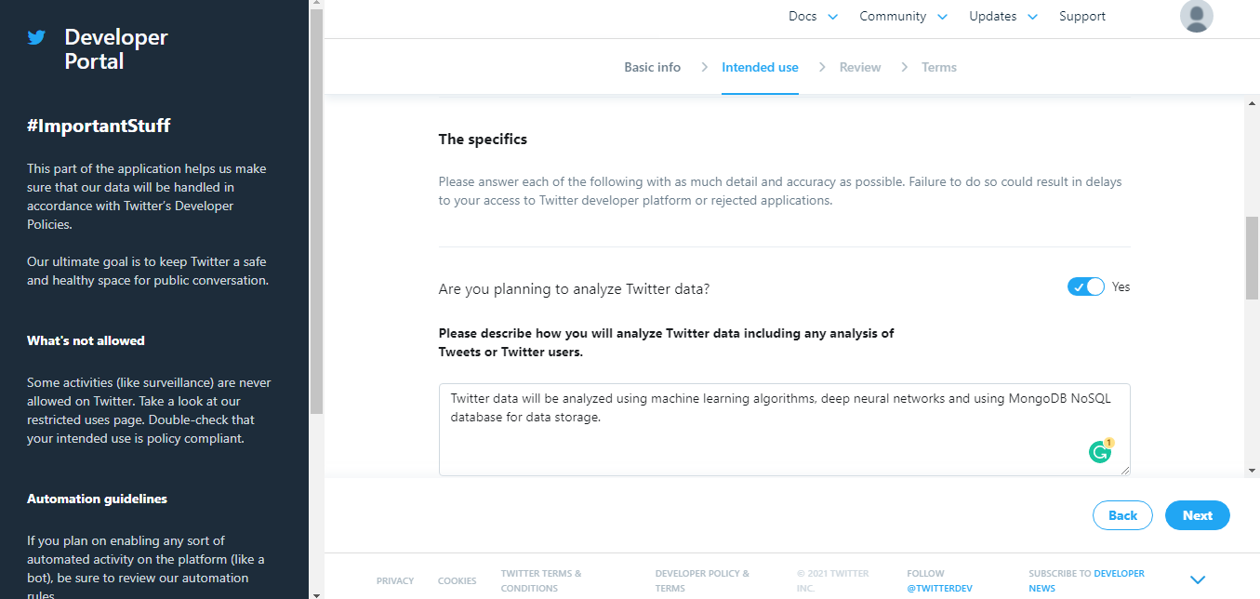

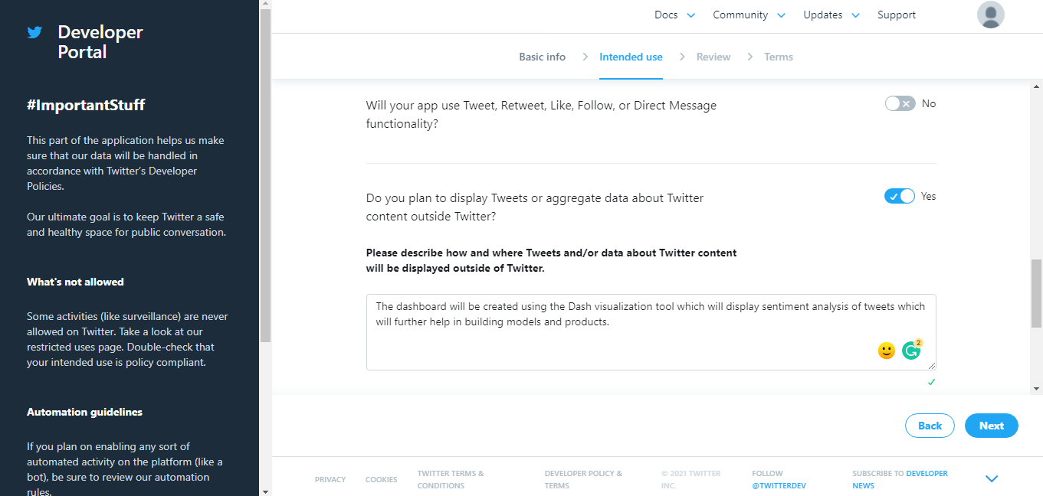

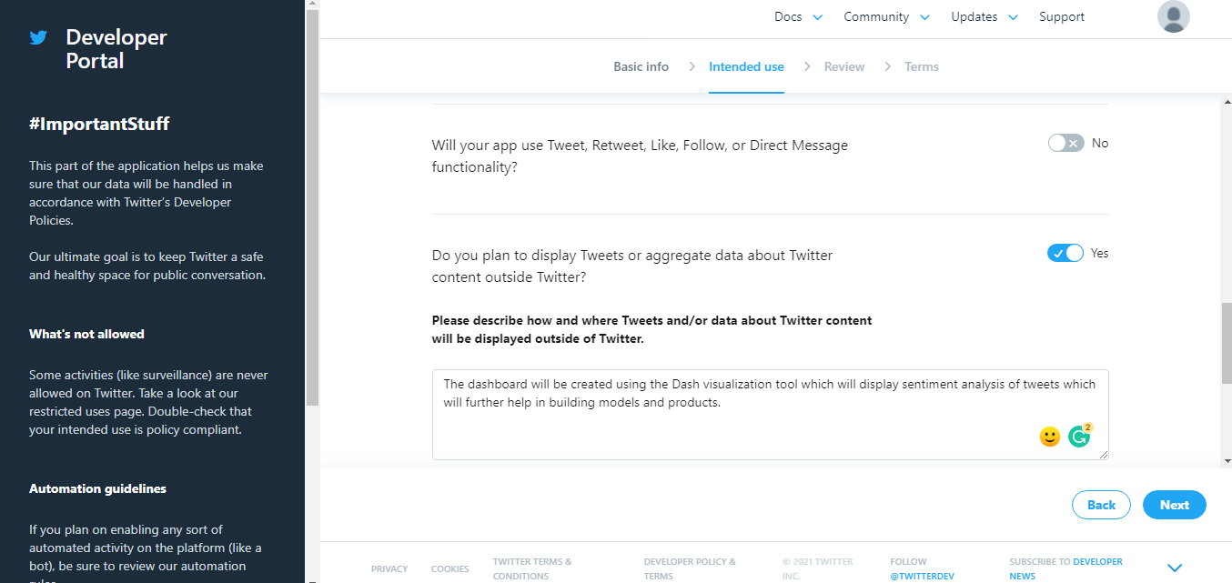

* Click on Start and proceed with the application

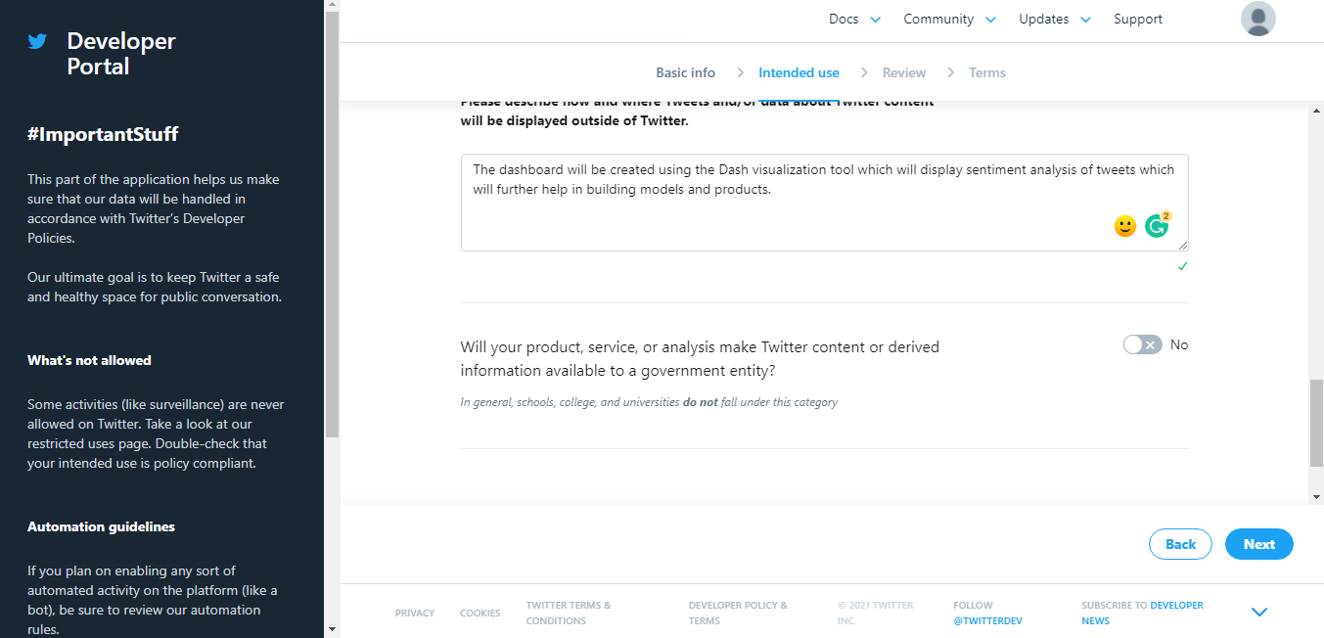

* Reviewing the Basic Info.

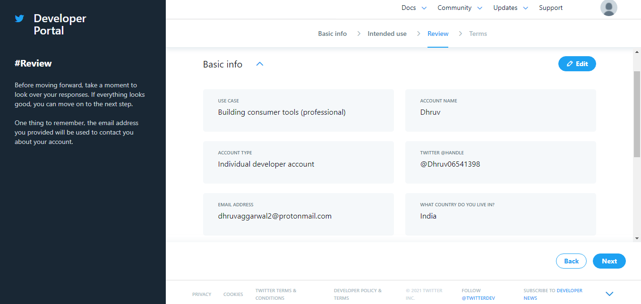

* Click on Next after reviewing the Basic Info.

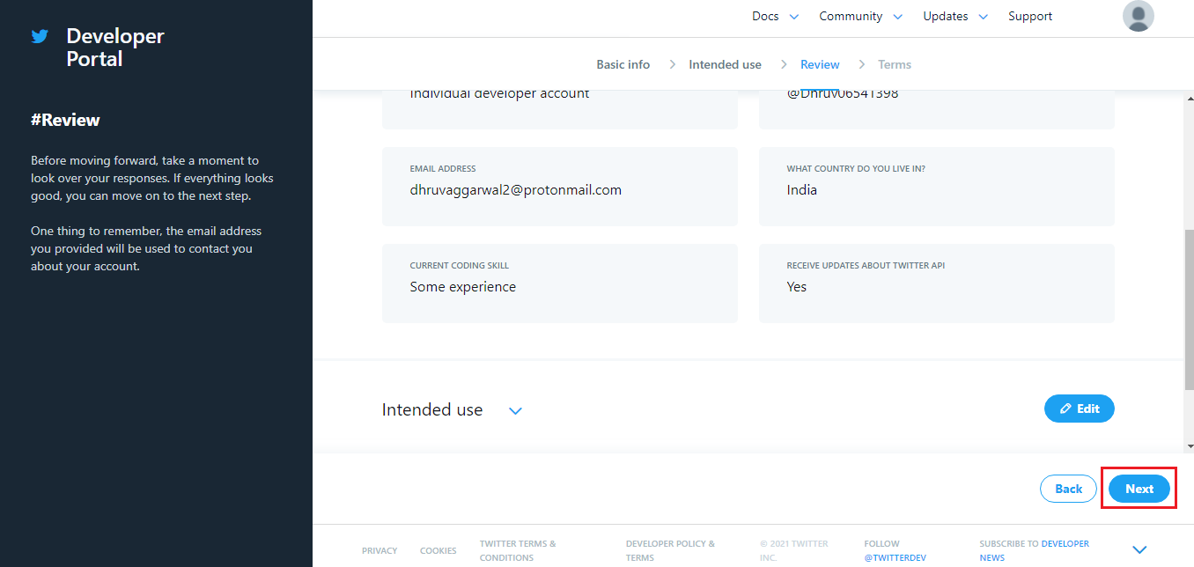

* Review the Terms and submit the application.

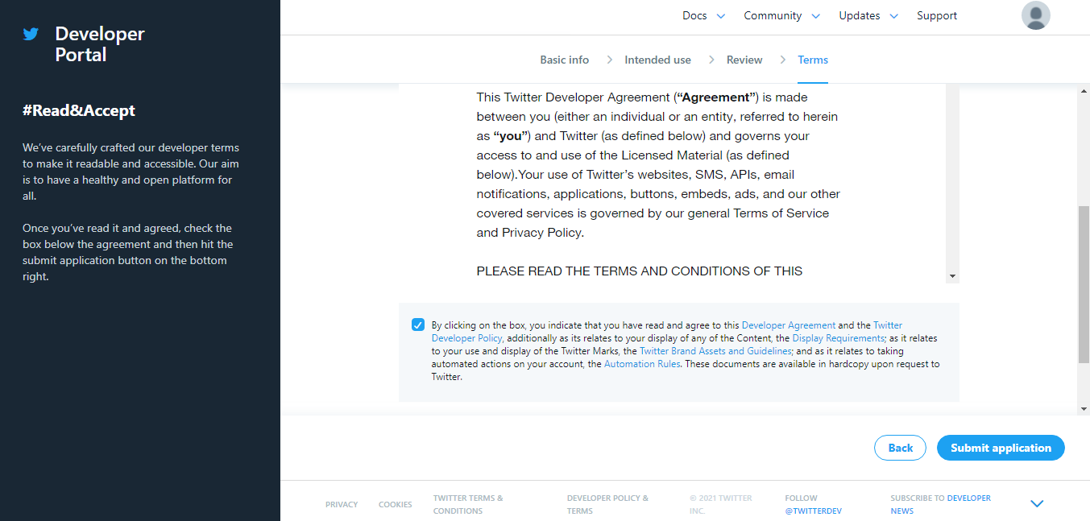

* An email will be sent to your email id for verification and confirmation.

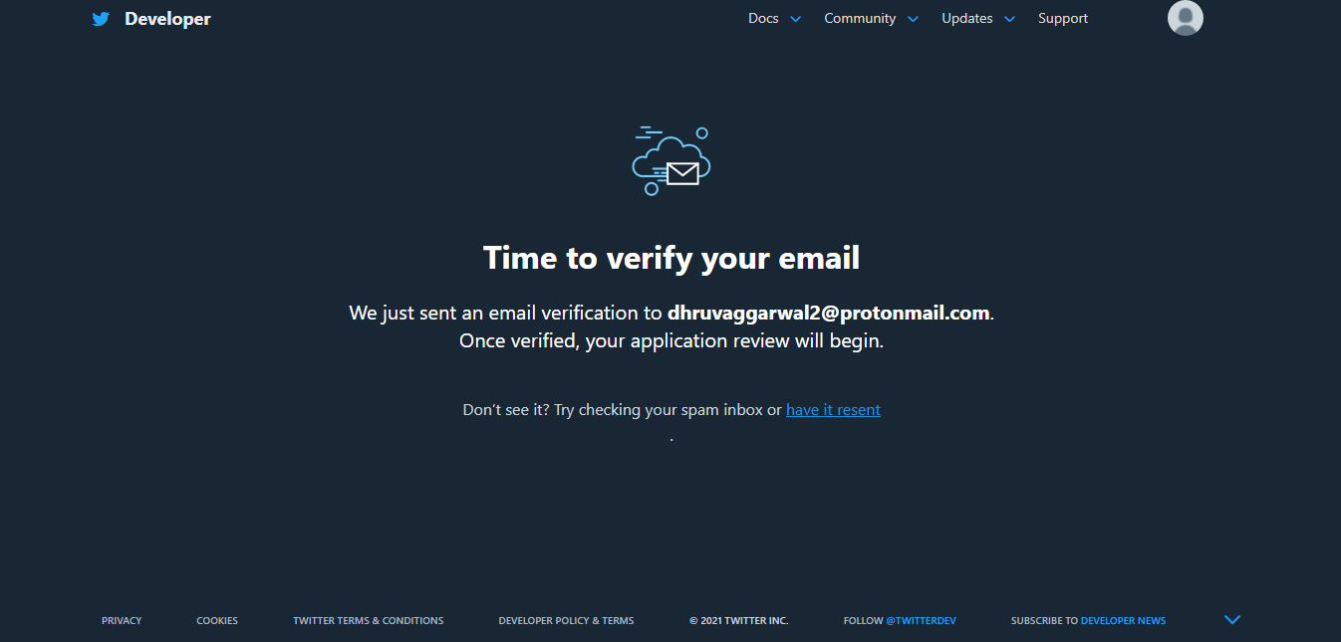

* After confirming the email, the application goes for review purpose and generally it takes 30 minutes for approval(If they find the information correct).  
  